# Virtual application Documentation

**Introduction**

The Virtual Bank application is a simulated fintech dashboard that allows users to manage digital financial services including wallets, bank accounts, and credit cards — all within a user-friendly web interface.

This documentation includes:

* A **User Guide** for people using the app
* A **Developer Guide** for contributors and maintainers

**User guide**

To begin using the virtual application

1. Enter your profile details
2. Fund either your bank or wallet
3. Add credit cards to your wallet
4. Begin using the application

### **2.2 Profile Management**

Navigate to the **Profile** section to add or edit the following:

* First Name
* Surname
* Email Address
* Mobile Number
* Gender
* Marital Status
* Location (Country, State, Postcode)
* Identification Type
* Identification Date
* Digital Signature

You’ll receive a notification when your profile is created or updated.

* *This screen shows the "update/edit" your profile page.*

### 

### **2.3 Wallet & Bank Account**

To perform the following actions a pin must be added when the app asks for it.

The default pin is 1025:

*This screen shows the authentication for "adding a pin" before an authentication can begin.*

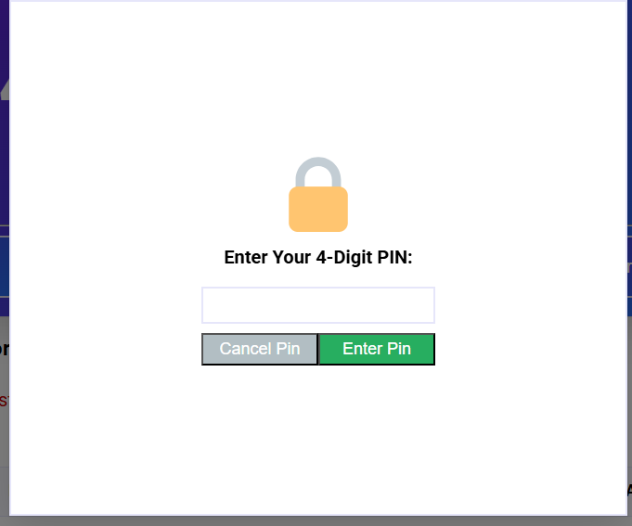

* Credit card management
* Funds Transfer

Users can:

* Add funds to a wallet
* Add funds to a bank account
* View balances
* Drain bank account

*This screen shows the overview functionality that can be done in the wallet*

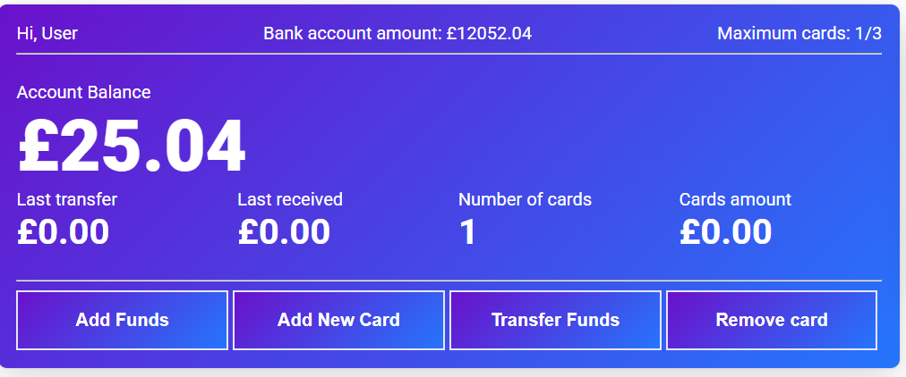

* *This screen shows the "Add Funds" to the bank account.*

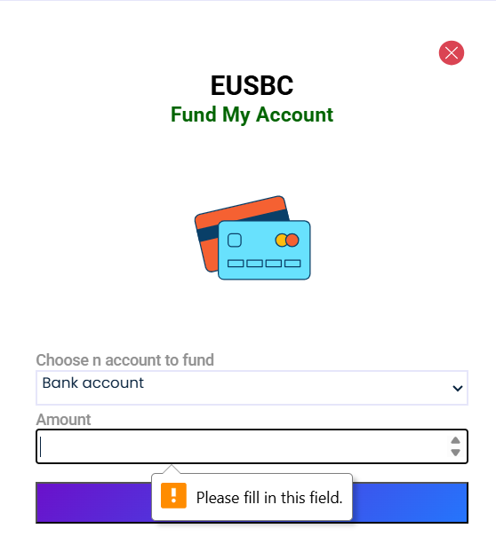

### 

* *This screen shows the "Add Funds" to the wallet.*

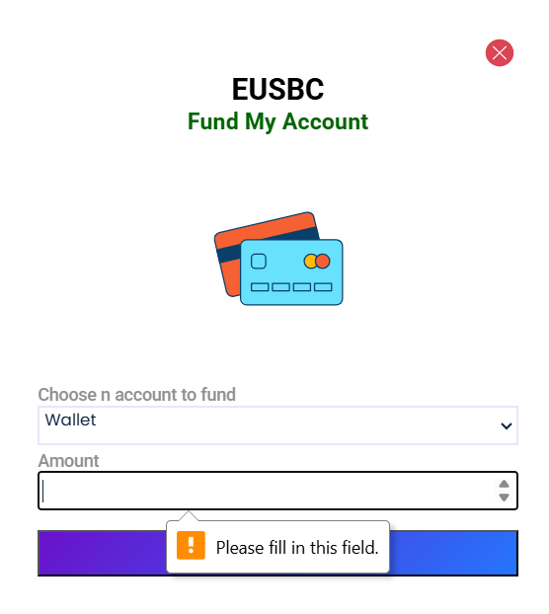

### **2.4 Credit Card Management**

* Add up to **three credit cards**
* Perform the following actions:
  + Block or unblock a card
  + Add funds to a card
  + Delete a card
  + Transfer funds:
    - Card to card
    - Card to wallet
    - Card to bank
* *This screen shows how to add a card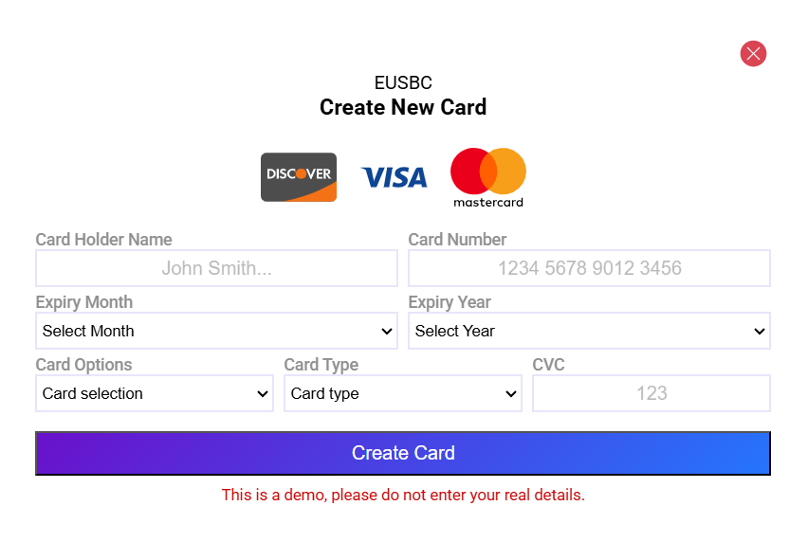*

### **2.5 Fund Transfers**

Supported transfer routes:

* Wallet ⇄ Bank
* Wallet ⇄ Card
* Bank ⇄ Card

### **2.6 Transaction History**

All transfers and changes are logged and visible under the **Transaction History** tab.

### **2.7 Notifications**

Users are notified in real time when:

* Transactions are made
* Cards are added
* Cards are removed
* Profile is added or updated

## **3. Developer Guide**

### **3.1 Tech Stack**

* **Frontend:** HTML, CSS, JS
* **Database:** LocalStorage
* **Hosting:** Github pages

**3.2 Project Structure**